PRESS RELEASE :
Singer Songwriter Piera Van de Wiel supports United Nations Trust Fund to End Violence Against Women
New Single “Used” is out now!
Date: (TBA) City: New York

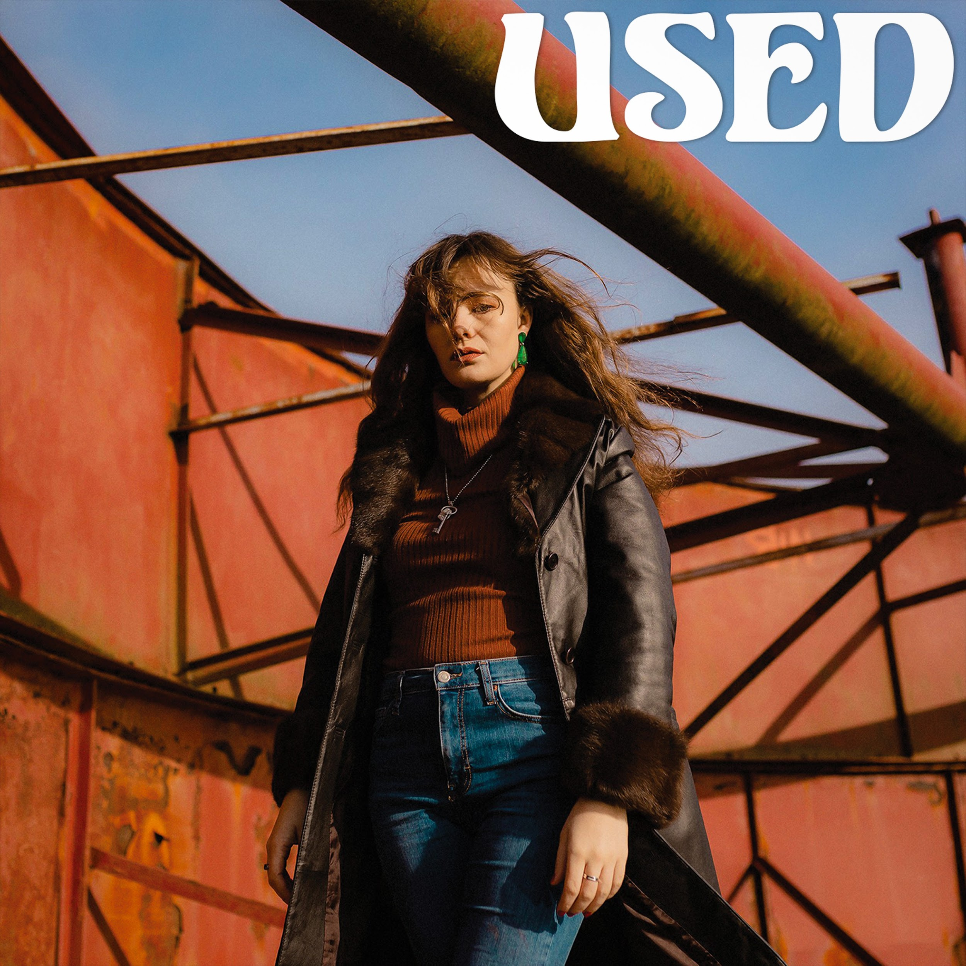
Through the power and medium of music, Singer songwriter Piera Van de Wiel is fundraising for women and girls who are survivors of violence with the United Nations Trust Fund to End Violence Against Women. This has been initiated through the new Spotify fundraiser option with a GoFundMe page (see here). This is extremely prevalent at this time of Covid-19, as domestic violence and abuse cases have increased exponentially all around the World.

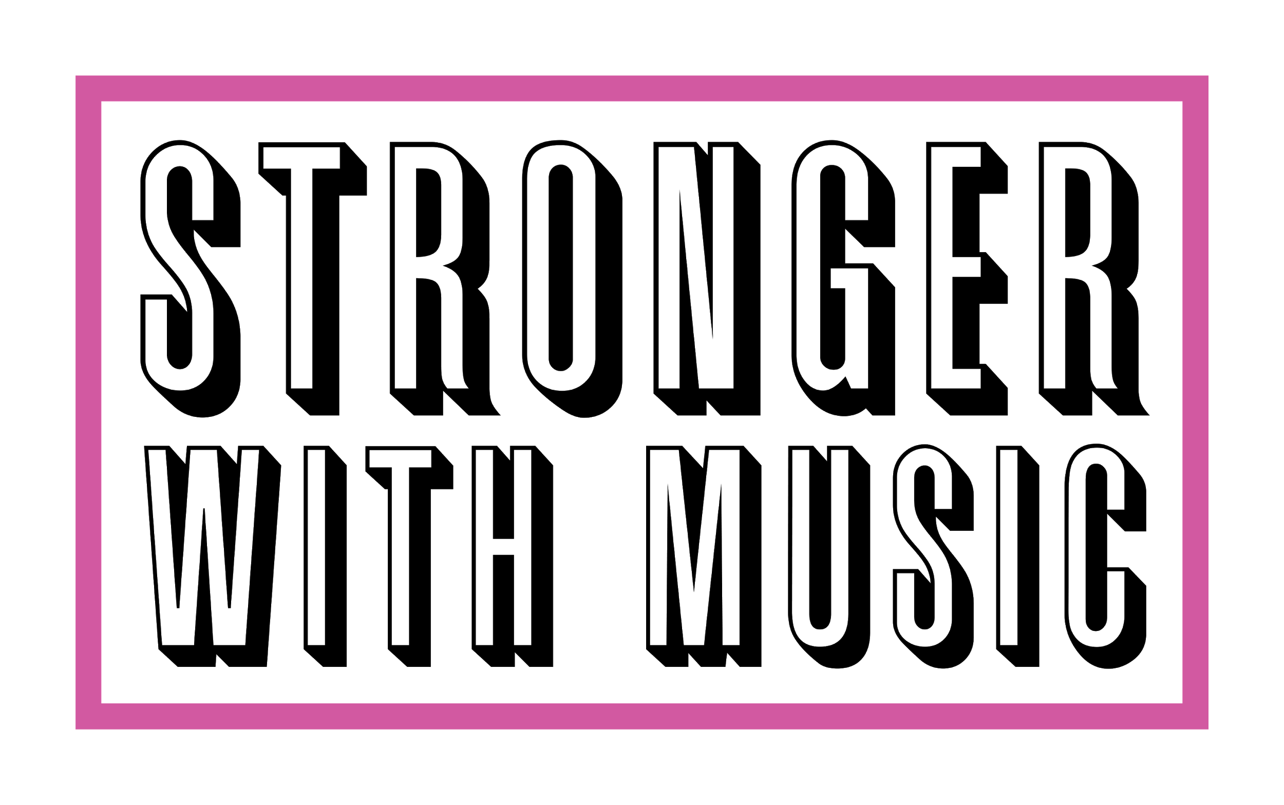
Piera Van de Wiel’s new single, “USED,” is out now on Spotify. This is an artist who is passionate about social impact, and understands how music can be used as a vehicle to increase awareness of Global Causes. Piera is the founder of her collective Stronger With Music that promotes the importance of Music and Mental Health and Music and Social Impact.

Her original composition "USED" is an emotional rollercoaster of how one can feel so safe when you let your barriers down only to feel used, abused and taken for granted, but ends with a lasting positive message of strength and hope.

Listen to her new song “USED” now on Spotify and consider donating!

Message from Songwriter and Founder of Stronger With Music Piera Van de Wiel:

“My goal as an artist is to use music as an avenue to benefit others, and with this initiative I aim to increase awareness of what is happening behind closed doors in isolated and quarantined homes globally, and raise money for the victims of Domestic Violence through this important mission between myself and the United Nations Trust Fund to End Violence Against Women. Please consider donating to the GoFundMe page and listening to my song “Used,” as you will be donating to a salient cause and helping women all over the world. Together we are using a new medium to raise awareness for Women and Girls that are victims to abuse and violence, thanks to Spotify’s new fundraising option.”

About the UN Trust Fund To End Violence Against Women

The United Nations Trust Fund to End Violence against Women (UN Trust Fund EVAW) is the only global grant-making mechanism exclusively dedicated to eradicating all forms of violence against women and girls. Since its establishment in 1996, it has supported over 550 initiatives in 140 countries and territories aiming to improve access to services for survivors of violence, changing harmful norms and attitudes to prevent violence and making laws and policies work for women. Every year, approximately 8 million people, including women and girls, men and boys, government officials and the general public, are reached by projects supported by the UN Trust Fund. In the context of COVID-19, there has been an alarming increase in violence against women and girls, as virus containment measures have exacerbated the shadow pandemic of violence against women. The UN Trust Fund provides life-saving support to women’s organizations, identified as first responders to women and girls who are victims of violence.

Please Consider donating to Piera Van de Wiel’s GoFundMe page

In the last two years Piera Van de Wiel has performed at United Nations sponsored international events through the Aspire Artemis Foundation, and she was introduced to the UN Trust Fund EVAW via Hermina Johnny:

“Placing women at the center of change and particularly during the Decade of Action for the achievement of the SDGS, the Aspire Artemis Foundation strongly supports the UN Trust Fund to End Violence Against Women and organizations at the forefront of taking action towards the awareness and eradication of all forms of violence, including domestic violence and abuse worldwide. We support and commend Piera Van de Wiel and Stronger With Music for leading this initiative.”

When Domestic Violence occurs there is dysregulation around emotional understanding, it is the lack of capacity to self-soothe emotionally. Music acts as a soothing mechanism. The relationship between Music and Domestic Abuse has been linked through Music therapy practices. Only recently this collective Stronger With Music hosted a panel “Music As A Reality Check” with two certfiied Music Therapists who spoke of the importance of the role that music plays when it comes to victims of abuse. We are Stronger With Music and as per Piera Van de Wiel’s mission, “We use our voices to let other voices be heard.”

Please Consider donating to Piera Van de Wiel’s GoFundMe page
And listen to her new single “Used!”

Website: www.pieravandewiel.com
Email: piera.vandewiel@gmail.com
Instagram: @pieravandewielofficial

